**SERVO MOTOR CONTROL USING TOUCH SWITCH**

**Introduction**

we use a touch sensor that acts as a switch whenever we touch it the servo motor gets starts rotating.We have to touch the sensor in order to on the Servo motor.. the touch sensor that we use in our project is the **TTP223** capacitive touch module that offers a one-touch key. The touch sensor generates a HIGH output when we touch it on its surface and LOW output for normal conditions.

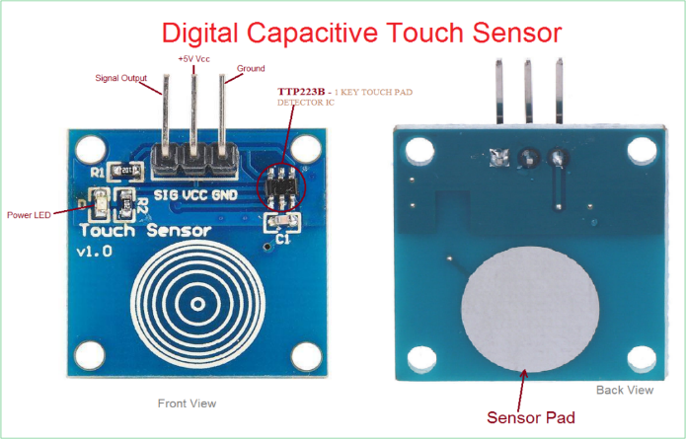

**Components**

* Arduino Uno Board
* TTP223 Capacitive Touch Sensor
* Servo Motor
* Breadboard
* Connecting Wires

**Application**

* robotics,
* CNC machinery
* automated manufacturing

**Objective**

During this activity ,you will help students to achieve following objectives

1. Understanding the principle and operation of touch sensor and servo motor control

2. Design algorithm and flowchart to rotate servo motor according to touch sensor

3. Programming touch sensor to rotate servomotor using Arduino uno

4. Interfacing touch sensor sensor withArduino uno

**Algorithm**

1. Initialise variable for servo motor control signal
2. Initialise touch sensor signal as input pin
3. Initialise LED as output pin
4. Check output of touch sensor and read value .
5. If output variable of sensor r=high and p=low ,then rotate servo motor 0 degree to 180 degree
6. Wait servo motor to reach position
7. If output variable of sensor r=low and p=high ,then rotate servo motor180 degree to 0 degree
8. Wait servo motor to reach position

**Flowchart**

**Programming**

#include <Servo.h>

Servo myservo;

int pos = 0;

int in = 2;

int out = 13;

int state = HIGH;

int r;

int p = LOW;

long time = 0;

long debounce = 200;

void setup()

{

myservo.attach(9);

pinMode(in, INPUT);

pinMode(out, OUTPUT);

}

void loop()

{

r = digitalRead(in);

if (r == HIGH && p == LOW && millis() - time > debounce) {

for (pos = 0; pos <= 180; pos += 1) { // goes from 0 degrees to 180 degrees

// in steps of 1 degree

myservo.write(pos); // tell servo to go to position in variable 'pos'

delay(5); // waits 15ms for the servo to reach the position

}

for (pos = 180; pos >= 0; pos -= 1) { // goes from 180 degrees to 0 degrees

myservo.write(pos); // tell servo to go to position in variable 'pos'

delay(5); // waits 15ms for the servo to reach the position

}

if (state == HIGH)

state = LOW;

else

state = HIGH;

time = millis();

}

digitalWrite(out, state);

p = r;

Hardware

Instuctions

1. Make connection such as VCC and GND of touch sensor is connected to the 5V and ground pin of arduin.
2. Connect signal out pin of sensor to the digital input pin (D2)of Arduino.
3. Connect servo motor supply voltage pin to Vcc and GND pin of arduino.
4. Connect servo motor control signal to digital pin (D3) of arduino
5. Connect LED output pin to Digital pin 5 of arduino.

